How to Value a Loss-Making Stock

Problem with high growth stocks
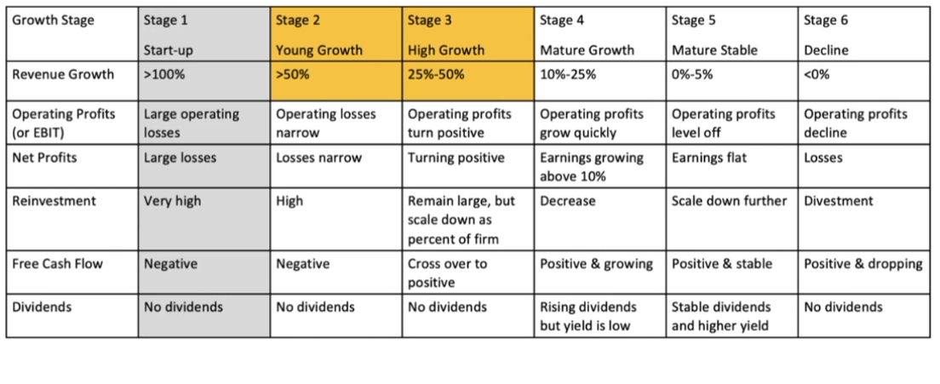

Two ways to fund a business
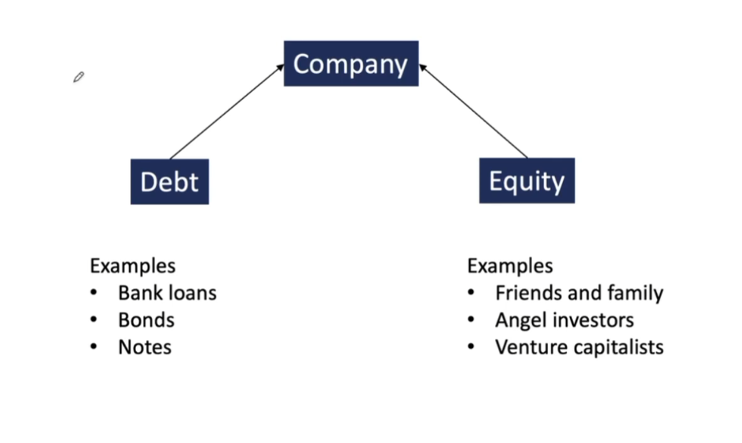
Companies that are ‘asset-light’ typically have to give away equity because they have nothing to use as collateral for bank loans etc.

Need capital to sustain loss-making periods.
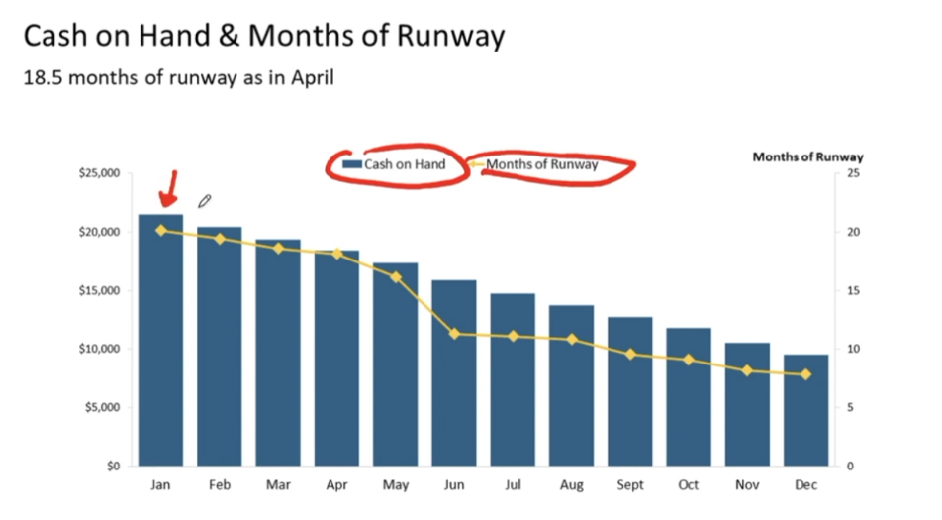
Consistently need to generate capital to do so.

Loss Making companies tend to have huge cash pile
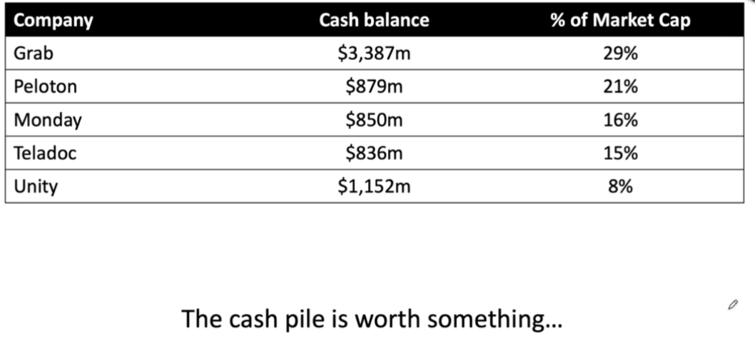

Price Ratio Ignores the cash

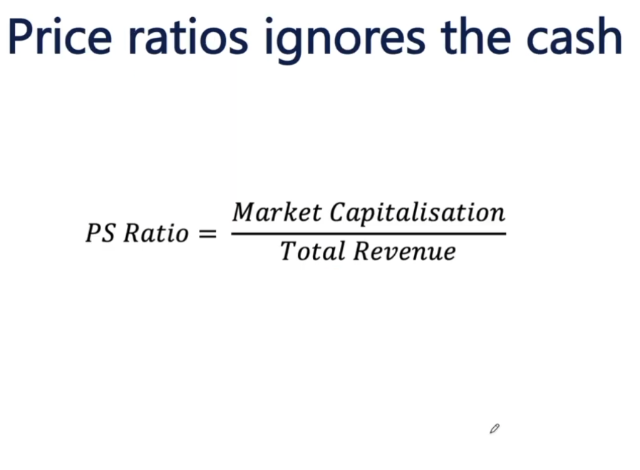Need a positive number to generate a real model for this. The PE ratio is obviously negative in a loss-making company. Cash is excluded therefore the PS ratio is not usable. Its important but not super useful.
Must use the enterprise value
Enterprise Value = Market Cap – Cash + Total Debt

Valuation largely depends on revenue growth rate
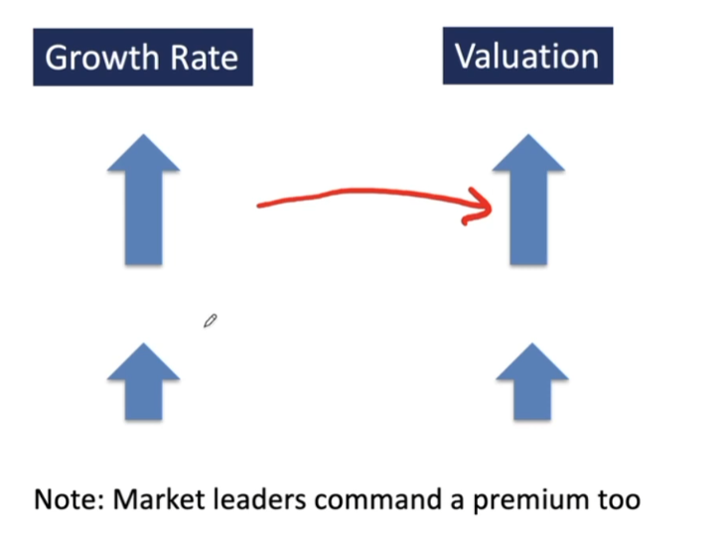
Market leaders ie open ai in the world of AI also command a premium. So maybe 60% of the valuation is the fact that it was novel and they were the market leader.

Historical =/= Forward Growth Rate
P/S (price to sales ratio) typically uses historical rev
Need: Future Growth
- Historical Revenue growth rate isn’t helpful.
- Future growth rate is more important
- Need to use Forward Revenue
- Can base this on management guidance or analysts’ consensus.
Formula to use going forward:
Enterprise Value/ Forward Revenue
Lower = cheaper
Do a peer comparison – always compare with something. Compare with other companies.
